Aim:
To implement procedure and triggers in SQL with two examples each on database Project assigned to each student, by running on WAMP/LAMP /XAMPP /SQL server.
Procedure :
- Search for XAMPP Control Panel in your device. Open XAMPP Control Panel on your device. The XAMPP control window will open.
- Click on the “Start” button for Apache server and MySQL server. The models will now be initialised. After the initialisation of models has taken place, the “Stop” button will appear.
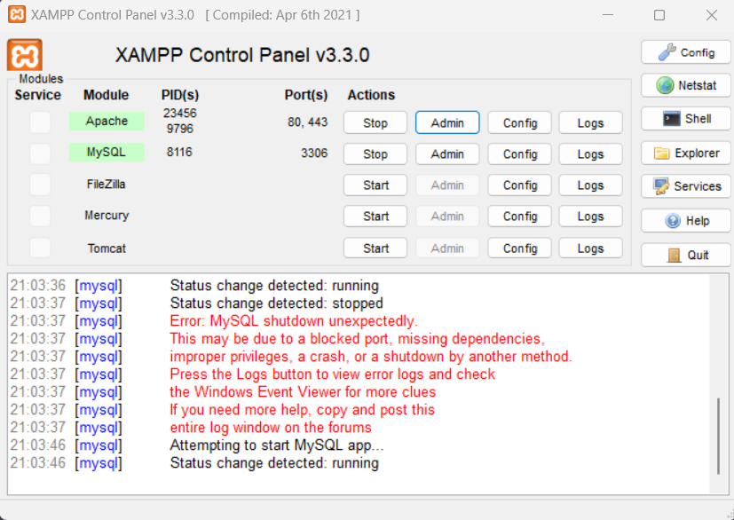
- Click on the “Admin” button next to the “Stop” button for MySQL server.
- After clicking on the “Admin” button, you will be redirected to http://localhost/phpmyadmin/.
.A trigger in MySQL is a stored program that automatically executes when a specific event occurs on a table. Here's how to create one:
- Go to the SQL tab in phpMyAdmin.
- Use the following SQL command to create a trigger. Modify it according to your table name (replace cutoffs with your actual table name).
Definition: A procedure in a database is a set of SQL statements stored under a name and executed as a single unit. Procedures are used to perform tasks such as data validation, business logic implementation, and automating repetitive operations. Unlike triggers, procedures are explicitly called by the user or an application

1: Implementing Procedures

Get Faculty by Department
QUERY: DELIMITER //
CREATE PROCEDURE GetFacultyByDepartment(
IN Dept VARCHAR(50)
)
BEGIN
SELECT Title, firstName, middleName, lastName, EMAIL_ID, AREA_OF_SPECIALIZATION
FROM faculty_data___staff_info_
WHERE DEPARTMENT = Dept;
END //
DELIMITER ;

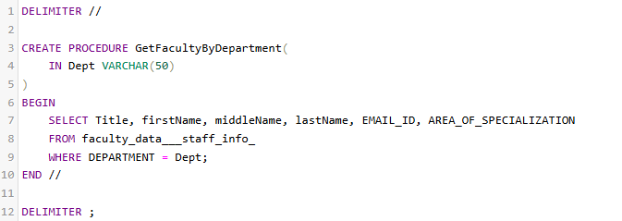

OUTPUT:

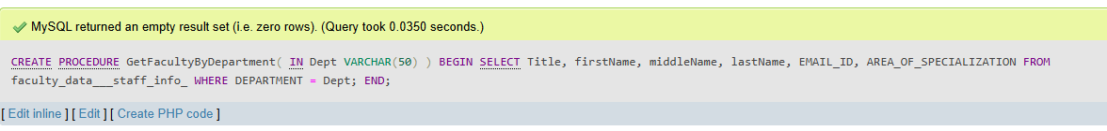

Procedure: 2. Update Printer Issue Status
This procedure allows updating the status of a printer issue based on the EMAIL_ID and Printer_model.
QUERY: DELIMITER //
CREATE PROCEDURE UpdatePrinterIssueStatus(
IN EmailID VARCHAR(50),
IN PrinterModel VARCHAR(50),
IN NewStatus VARCHAR(50)
)BEGIN
UPDATE printer_issue_detail
SET Status = NewStatus
WHERE EMAIL_ID = EmailID AND Printer_model = PrinterModel;
END //
DELIMITER ;

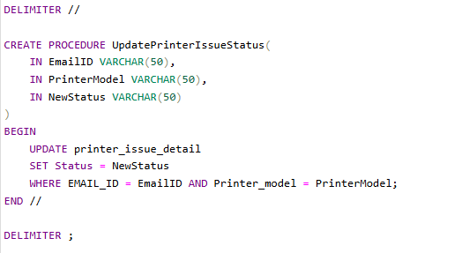

OUTPUT:

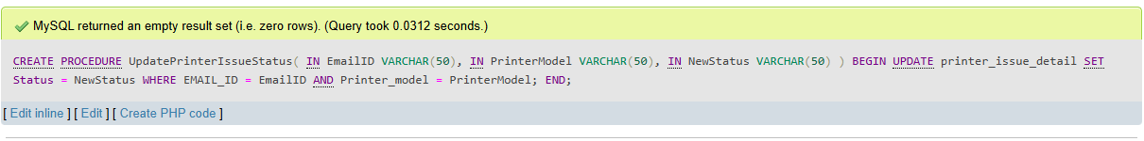

Implementing Triggers

Ensure Unique Email for Faculty
A trigger that ensures the EMAIL_ID is unique in the faculty_data___staff_info_ table.

Validate Email Domain for Faculty
This trigger ensures that the EMAIL_ID follows the domain @ccet.ac.in.
QUERY: DELIMITER //
CREATE TRIGGER ValidateEmailDomain
BEFORE INSERT ON faculty_data___staff_info_
FOR EACH ROW
BEGIN
IF NEW.EMAIL_ID NOT LIKE '%@ccet.ac.in' THEN
SIGNAL SQLSTATE '45000'
SET MESSAGE_TEXT = 'Error: EMAIL_ID must contain the domain @ccet.ac.in.';
END IF;
END //
DELIMITER ;

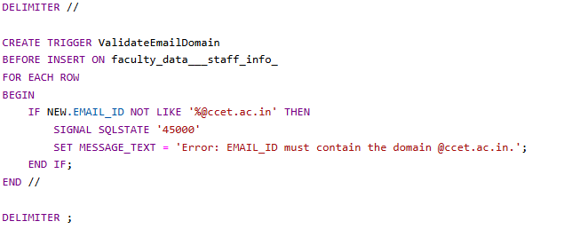
OUTPUT

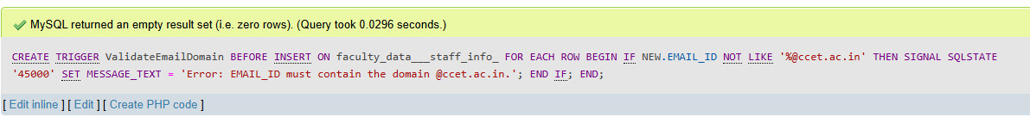

2.Trigger: Ensure Valid Room Number
This trigger ensures that a valid ROOM_NO (not null or empty) is provided when adding a new faculty member to the faculty_data___staff_info_ table.
QUERY:
DELIMITER //
CREATE TRIGGER ValidateRoomNumber
BEFORE INSERT ON faculty_data___staff_info_
FOR EACH ROW
BEGIN
IF NEW.ROOM_NO IS NULL OR NEW.ROOM_NO = '' THEN
SIGNAL SQLSTATE '45000'
SET MESSAGE_TEXT = 'Error: ROOM_NO cannot be null or empty.';
END IF;
END //
DELIMITER ;
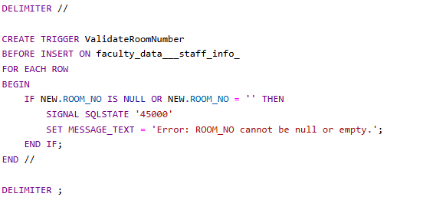

OUTPUT:

